Software Requirements Specification

for

After12th.com Website

**Version 1.0 approved**

**Prepared by 21CE124, 21CE125, 21CE126, 21CE135**

**CSPIT-CE**

**01-10-22**

**Table of Contents**

**Table of Contents Error! Bookmark not defined.**

**Revision History** 3

**1.** **Introduction Error! Bookmark not defined.**

1.1 Objective **Error! Bookmark not defined.**

1.2 Document Conventions **Error! Bookmark not defined.**

1.3 Intended Audience and Reading Suggestions **Error! Bookmark not defined.**

1.4 Project Scope **Error! Bookmark not defined.**

1.5 References **Error! Bookmark not defined.**

**2.** **Overall Description Error! Bookmark not defined.**

2.1 Product Perspective **Error! Bookmark not defined.**

2.2 Product Features **Error! Bookmark not defined.**

2.3 User Classes and Characteristics **Error! Bookmark not defined.**

2.4 Operating Environment **Error! Bookmark not defined.**

2.5 Design and Implementation Constraints **Error! Bookmark not defined.**

2.6 User Documentation **Error! Bookmark not defined.**

2.7 Assumptions and Dependencies **Error! Bookmark not defined.**

**3.** **System Features Error! Bookmark not defined.**

3.1 System Feature 1 **Error! Bookmark not defined.**

**4.** **External Interface Requirements Error! Bookmark not defined.**

4.1 User Interfaces **Error! Bookmark not defined.**

4.2 Hardware Interfaces **Error! Bookmark not defined.**

4.3 Software Interfaces **Error! Bookmark not defined.**

4.4 Communications Interfaces **Error! Bookmark not defined.**

**5.** **Other Nonfunctional Requirements Error! Bookmark not defined.**

5.1 Performance Requirements **Error! Bookmark not defined.**

5.2 Safety Requirements **Error! Bookmark not defined.**

5.3 Security Requirements **Error! Bookmark not defined.**

5.4 Software Quality Attributes **Error! Bookmark not defined.**

**6.** **Other Requirements Error! Bookmark not defined.**

**Appendix A: Glossary Error! Bookmark not defined.**

**Appendix B: Analysis Models Error! Bookmark not defined.**

**Appendix C: Issues List Error! Bookmark not defined.**

**Revision History**

|  |  |  |  |
| --- | --- | --- | --- |
| **Name** | **Date** | **Reason For Changes** | **Version** |
|  |  |  |  |
|  |  |  |  |

# 1) Introduction

## 1.1 Introduction

We are designing a website to ease any 12th passed out student to find his dream university for his chosen branch. This website will help students who have no idea what to choose after 12th, what to do?

We are providing 6-7 branches definations, which will help students to decide the interest.

**1.2 Document Conventions**

We have chosen fonts and highlighted certain information which will be reader friendly.

## 1.3 Intended Audience and Reading Suggestions

The students who appeared for the 12th boards and they don’t know about any engineering branches. And the universities according to the branch they choose.

## 1.3 Project Scope

The basic motto of this project is to make the student clear that in branch they want to make future.

The purpose of this website is to give the confused students the perfect idea about what they need to do. Our website provides all the necessary details needed by the students to choose their dream branch and help them selecting the right path for their safe and successful future.

**1.4 References**

Reference we took from multiple branches serving same concept as ours and university decider and cut offs from various different websites. And taking the ideas from all the websites. We have taken reference from collegesearch.in , jacpcldce.ac.in.

Reference has also been taken from web designing and development tutorials.

# 2 Overall Description

The website helps the students to help find them the future goal. The branch they want to choose and pursue the branch they want.

**2.1 Website features**

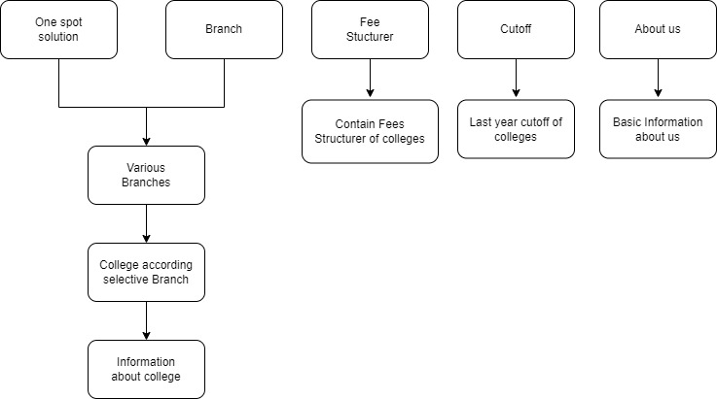

## 2.2 User Classes and Characteristics

The user of the system will able to get important information about universities. The user will able tocompare different universities which will help them choose them the best which fits them.

The user classes : Students

Students will be given information of previous cutoff, closing rank, fee structure of different universities giving then better idea so that they can compare their current marks and percentile estimating their chance of getting admission in the particular universities.

## 2.3 Operating Environment

> Operating environment for our retailed website is as listed below.

> Operating system: Windows

> Platform: HTML/CSS

## 2.4 Design and Implementation Constraints

*<Describe any items or issues that will limit the options available to the developers. These might include: corporate or regulatory policies; hardware limitations (timing requirements, memory requirements); interfaces to other applications; specific technologies, tools, and databases to be used; parallel operations; language requirements; communications protocols; security considerations; design conventions or programming standards (for example, if the customer’s organization will be responsible for maintaining the delivered software).>*

|  |  |  |  |  |
| --- | --- | --- | --- | --- |
| **3rd Sem** | **4th Sem** | **5th Sem** | **6th Sem** | **7th Sem** |
| Not required | Not Required | Not Required | Mandatory | Mandatory |

## 2.5User Documentation

The website will guide you through the top universities in your choice of interest. It will provide you information about the universities which includes university official link, fees, ranking and exam required.

## 2.6 Assumptions and Dependencies

The main assumption of this project is that the user will be provided with plentiful information about their dream university which will help them choosing the best and it will save their time and energy as they do not need to surfing other websites for the information.

# 3 System Features

## 3.1 System Feature 1

3.1.1 **Description and Priority**

* The website will guide them in choosing best college according

to their field of interest.

* Providing them with the reviews given by the students who are

currently studying in the college for a honest review of the

college.

* + 1. **Stimulus/Response Sequences**
* Search for varieties of different college with different fields and display previous year merit rank.
* Displays a detailed list of different colleges of selected branch by user.
* Clients can get information about fees structure of different colleges with corresponding fields.

3.1.3 **Functional Requirements**

* The website should be able to sow you different types of colleges according to your dream Branch. This website also contain College website link, Required entrance exam, Website link for that exam Fees of that college etc.

# 4 External Interface Requirements

## 4.1User Interfaces

Front-end Software: Visual studio code.

4.2**Hardware Interfaces**

Windows

Browser which supports CSS,HTML

## 4.3 Software Interfaces

Following are the software used for the our online showroom website.

|  |  |
| --- | --- |
| **Software used** | **Description** |
| Operating system | We have chosen Windows operating system for its best support and user-friendliness. |
| Visual studio code | To implement the project we have chosen HTML,CSS, language for its more interactive support. |

## 4.4 Communications Interfaces

This project supports all types of web browsers.

**5 Other Nonfunctional Requirements**

## 5.1 Performance Requirements

As the project is web based so there are no specifications for performance but in further updates of the project the student can select for desired competitive exams and they can apply for same and also get reminder.

## 5.2 Safety Requirements

*<Specify those requirements that are concerned with possible loss, damage, or harm that could result from the use of the product. Define any safeguards or actions that must be taken, as well as actions that must be prevented. Refer to any external policies or regulations that state safety issues that affect the product’s design or use. Define any safety certifications that must be satisfied.>*

|  |  |  |  |  |
| --- | --- | --- | --- | --- |
| **3rd Sem** | **4th Sem** | **5th Sem** | **6th Sem** | **7th Sem** |
| Not Required | Not Required | Required, if requirement needs | Required, if requirement needs | Required, if requirement needs |

## 5.3 Security Requirements

*<Specify any requirements regarding security or privacy issues surrounding use of the product or protection of the data used or created by the product. Define any user identity authentication requirements. Refer to any external policies or regulations containing security issues that affect the product. Define any security or privacy certifications that must be satisfied.>*

|  |  |  |  |  |
| --- | --- | --- | --- | --- |
| **3rd Sem** | **4th Sem** | **5th Sem** | **6th Sem** | **7th Sem** |
| Not Required | Not Required | Required, if requirement needs | Required, if requirement needs | Required, if requirement needs |

## 5.4 Software Quality Attributes

* **AVAILABILITY:** Our retailed website is available 24*7.
* **CORRECTNESS:** The user can get realistic numbers about merit ranks and fees.
* **MAINTAINABILITY:** The college administrators and client should maintain correct data about college.
* **USABILITY:** The web should satisfy user’s expectation with applicable colleges and branches*.*